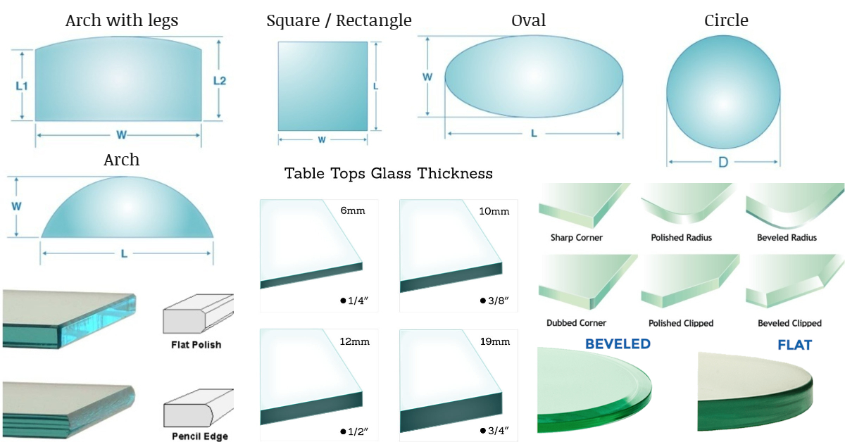

|  |  |  |  |  |
| --- | --- | --- | --- | --- |
| Quantity  _______ | Exact Size  W________ x L _________  *Circle  Diameter_____________  *Arch with legs  Leg height____________ | Glass thickness  1/4  3/8  1/2  3/4 | Glass type  Annealed  (standard glass)  Tempered  (Safety glass) | Edgework  None  Seam  Flat Polish  Pencil Polish  Bevel  No ½ ¾ 1  1 ¼ 1 1/2 |

|  |  |
| --- | --- |
| Date__________ Quote Only / Order  Customer Name________________  Phone Number_________________  Email Address__________________  Address if delivery______________  ______________________________  *Please fill out all required information. All glass is ordered to customer specifications. We are not responsible for your measurements. Allow 1/16 differential. Glass only orders require payment in full upfront. If you want us to measure the glass on site or in shop there is an extra fee. Delivery of glass is an extra fee. Please allow 5-7 business days for most common shelves and tabletops. | Drawings / Extra Hardware List |