Glass Only Order Form – Insulated Glass – Valleywide Glass

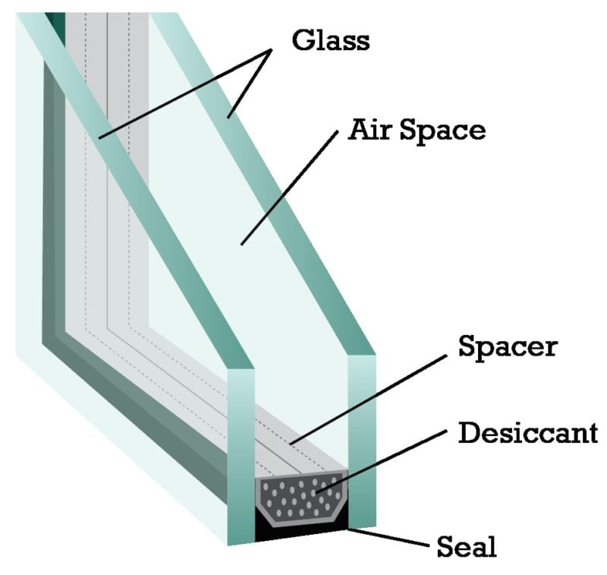

Quote Only - Ready to order

|  |  |  |  |  |
| --- | --- | --- | --- | --- |
| Quantity | Unit Size  ______w X _______h | Overall Thickness ________  Spacer  Bronze / Mill | Glass Color  Clear, Bronze, Gray, Obs, Low-E  Other_________ | Glass thickness  1/8  3/16  1/4 |
| Glass type  Annealed  Tempered  Laminated | Grid Pattern?  ______ x _______ | Grid Size  1/2 9/16  5/8 3/4  1” sculptured | Grid Color  Champagne  White  Bronze  Almond  Mill | Glazing Bead  ____________  Color  ___________  Feet |

|  |  |
| --- | --- |
| Date__________  Customer Name________________  Phone Number_________________  Address if delivery______________  ______________________________  *Please fill out all required information. All glass is ordered to customer specifications. Allow 1/16 differential. Glass comes with 5 year warranty against seal failure/ moisture between the panes. Glass only orders require payment in full upfront. Delivery of glass is an extra fee. Please allow 5-7 business days for most common insulated glass units. | Draw the unit here |

Sales Rep____________ Date_______Price______________ Turnaround time_____________________